1. We first created the layout for our auth.

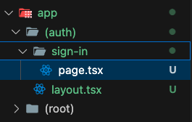

1. Then we updated the layout code.

1. Then we added the design and metadata for the sign-in route page.

